Fourth Grade News Letter From Sister Navya’s Classroom (11/26 - 11/30)
http://grade4-sjbschool.weebly.com sr.navya@sjb-school.org
Language Arts  This week we will be reading a biography. Students will  - describe a character in depth  - refer to details and examples in a text when explaining what the text says explicitly and when drawing inferences from the text  - use correct capitalization  - identify and use pronouns correctly | Upcoming Events  30 - Library  Bible Verse for the week  Isaiah 41:10  “Fear not, for I am with you; be not dismayed, for I am your God.”  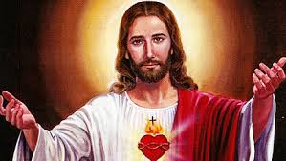  Reminders:  Practice multiplication facts.  Friday – spelling test | 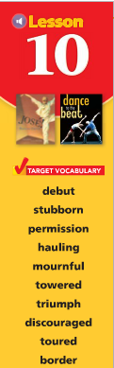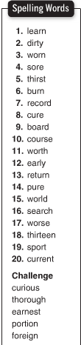  Spelling test on Friday (11/30/18)
Math
Students will
-estimate products rounding and compatible numbers
-write estimates and products of 3-digit whole numbers multiplied by 2-digit whole numbers
-practice multiplication using money
- solve multistep problems
Science
Students will
- demonstrate how an electric current can produce a magnetic force
- construct an electromagnet to pick up paperclips
Religion
Students will
-explore how worldly justice and God’s justice differ
-realize that we are called to live holy lives

