Fourth Grade News Letter From Sister Navya’s Classroom (4/8 – 4/12)
http://grade4-sjbschool.weebly.com sr.navya@sjb-school.org
Language Arts:  This week we will be reading expository nonfiction.  Students will  -determine the main idea of a text and explain how it is supported by key details; summarize the text  - use context as a clue to the meaning of a word or phrase | Dates to Remember in  April  4/11 – Report cards go home  4/12 – Lenten retreat  4/19 – Good Friday ( No School)  4/ 22 – Easter Monday ( No School)  4/ 26 – Hot lunch, Poetry pause  Stations of the Cross on Mondays at 3:00 P.M.  Bible Verse  Reminders:  Homework – online practice of pronouns in ixl.com EE.4 - 9  Friday: spelling test  Lenten Retreat | 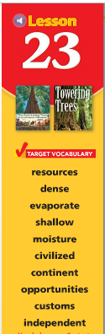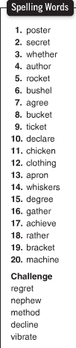  Spelling test on Friday  4/12/2019
Math -
Students will
-estimate the circumference of circles
-estimate the area
-relate area and perimeter
-calculate the area of rectangles
-identify solid figures by their faces, edges and vertices
-identify solid figures by their patterns or net

Social Studies – The Southwest
Students will:
-describe physical features of the Southwest
-Understand how people in the Southwest use natural resources
- make slides for State presentation

Science: How Our Body Works
Religion - The Commandments and Forgiveness
Students will:
-learn the meaning of conscience and how it is correctly formed and developed
-understand that the Seventh through Tenth Commandments teach us to treat others in loving and unselfish ways

