Fourth Grade News Letter From Sister Navya’s Classroom (4/15 – 4/18)
http://grade4-sjbschool.weebly.com sr.navya@sjb-school.org
Language Arts:  This week we will be reading narrative nonfiction.  Students will  -determine the main idea of a text and explain how it is supported by key details; summarize the text  -use common, grade-appropriate Greek and Latin affixes and roots as clues to the meaning of a word  -use context as a clue to the meaning of a word or phrase. | Dates to Remember in  April  4/19 – Good Friday ( No School)  4/ 22 – Easter Monday ( No School)  4/ 26 – Hot lunch, Poetry pause  Stations of the Cross on Mondays at 3:00 P.M.  Bible Verse  Reminders:  Monday – Stations of the Cross (Gr.4)  Thursday: spelling test | 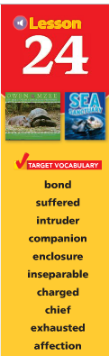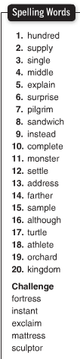  Spelling test on Thursday  4/18/2019
Math -
Students will
-estimate the area
-relate area and perimeter
-identify solid figures by their faces, edges and vertices
-identify solid figures by their patterns or net

Social Studies – The Southwest
Students will:-understand cultural diversity in Texas and Oklahoma
-describe the growing economy of Arizona and New Mexico
- make slides for State presentation

Science:
Religion -
Students will:
-learn the meaning of conscience and how it is correctly formed and developed
- discover special times of the year
-describe the celebration of Triduum

