Fourth Grade News Letter From Sister Navya’s Classroom (4/29 – 5/3)
http://grade4-sjbschool.weebly.com sr.navya@sjb-school.org
Language Arts:  This week we will be reading science fictions.  Students will  -determine the main idea of a text and explain how it is supported by key details; summarize the text  -use common, grade-appropriate Greek and Latin affixes and roots as clues to the meaning of a word  -use context as a clue to the meaning of a word or phrase. | NWEA - SPRING TEST STARTS THIS WEEK  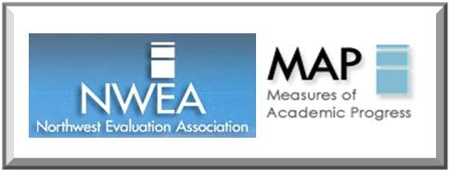  Bible Verse  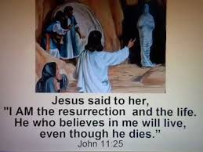  Reminders:  Wednesday – NWEA MAP test (Reading)  Thursday – NWEA MAP test (Language Use)  Friday – spelling test | Spelling test on Friday  5/3/2019  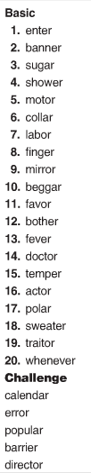  Lesson 26  peculiar  intends  captured  nourishing  glances  observes  assist  favor  condition  memorable
Students will
-multiply decimal numbers
-multiply fractions
- work with percentages
Social Studies – Exploring the Southwest
Students will
-understand cultural diversity in Texas and Oklahoma
-describe the growing economy of Arizona and New Mexico
-read and interpret graphic information given on maps
-use a map to find actual distance between places on a road map
Science – Healthy Living
Students will
-explain the need of nutrients, carbohydrates, vitamins, minerals, water and proteins for keeping our body healthy

Religion -The Commandments and praying for Forgiveness
Students will
-recognize ways we can follow Jesus’ example of forgiveness
-name ways Christians share God’s forgiveness with others
-recognize that the Seventh through Tenth Commandments require us to respect others and care for the rights of others

