Fourth Grade News Letter From Sister Navya’s Classroom (5/6 – 5/10)
http://grade4-sjbschool.weebly.com sr.navya@sjb-school.org
Language Arts:  This week we will be reading science fictions.  Students will  -determine the main idea of a text and explain how it is supported by key details; summarize the text  -use common, grade-appropriate Greek and Latin affixes and roots as clues to the meaning of a word  -use context as a clue to the meaning of a word or phrase. | Dates to Remember  May  9 – MOA Field Trip  10 – Rosary at 3:00PM  13 – Spring Musical  17 – K- 4 Field Trip  Rosary at 3:00 PM  20 - 4th Grade States Presentation at 2:45 PM (All are welcome)  24 – Rosary at 3:00 PM  27 – No School  31 – Mini Courses  Bible Verse  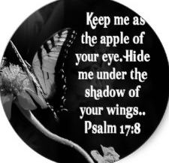  Tuesday – NWEA MAP test (Math) | Spelling test on  Monday 5/13/2019  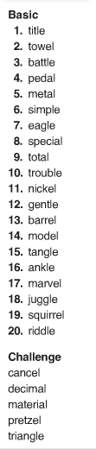  Lesson 27  shortage  betrayed  species  continent  scarce  focus  included  alert  introduce  opportunities
Math
Students will
-multiply decimal numbers
-multiply fractions
- work with percentages

Social Studies – Exploring the Southwest
Students will
-understand cultural diversity in Texas and Oklahoma
-describe the growing economy of Arizona and New Mexico
-read and interpret graphic information given on maps
-use a map to find actual distance between places on a road map

-Make slides for States presentation
Religion -The Commandments and praying for Forgiveness
Students will
-recognize ways we can follow Jesus’ example of forgiveness
-name ways Christians share God’s forgiveness with others
-recognize that the Seventh through Tenth Commandments require us to respect others and care for the rights of others

